3rd Generation Paperless Case Management for Investigators and Analysts
White Paper, March 2018

Executive Summary
Spreadsheets or shared website folders don’t cut it any more for tracking “cases” or pieces of work for government agencies. Computer are a must in all aspects of every person’s life to keep up. This affected how work is actually done from one industry sector to another. First computer technology affected the financial sector, then the manufacturing sector, and latest generation computer power is working for the more complicated investigative and intelligence case management sector.
The latest change in the manufacturing sector was from a paper-to-keypunch process to a paperless-online transaction process. The inventory transaction of today is done without any paper into the quickly changing, more user-friendly personal computer. This makes for a real-time system—the actual movement of a piece of inventory is known by all those with access to the system at nearly the same time the event occurred. Now, the more complex work of the law enforcement investigator and intelligence analyst is poised to make a similar jump. The questionable event/incident/person is known by the entire agency at nearly the same time the trigger occurred. Software and hardware have existed for the investigators for some time but in a limited capacity. The investigator used word processors for creating the needed documentation for their clients. The investigator used databases to look up information about a person, place, or property to assist in the research aspects of the job. More advanced investigative and intelligence agencies currently use databases to capture the workproducts and metrics on these products (for example, records management systems, document exploitation, document scanning).
The next generation of information management tools for investigative and intelligence agents is called an Activity Based system. The Investigative Information Management System (I2MS) is one of the first of these Activity Based systems for investigative processes. An Activity Based system is meant to capture all tasks done (and yet to be done) by the agent. It documents agent “Tooth to Tail” processes without the less efficient paper forms for entry by a data entry person.
With this broad coverage, an Activity Based system serves several information technology purposes for the agent in one package:
▪ Documentation generator for the agent clients
▪ Database repository for agent research on people, places, or property
▪ Resource allocation for agent management responsibilities
▪ Database warehouse for command wide metrics of cases (auto generation to NIBRS/DIBRS)
▪ Evidence, equipment, source, and expense management in the context of the cases
▪ Agent collaboration (notifications, leading, chat)
This paper will discuss the system concepts and features of the Activity Based system, the advantages of these systems, and their architectural considerations.

System Concepts and Features
The Activity Based system, which captures all aspects of investigative work, requires a bird’s eye view of what the organization does in the context of the investigative work.
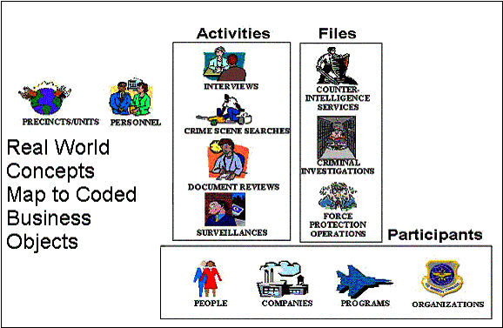

Investigative Organization Concepts--The investigative organization, be it insurance, environmental, educational, DoD, or public, gathers the investigative information in similar ways. The organization is made up of teams or units of personnel who perform Activities or tasks. These Activities are done involving different participants with different roles. The cases against these participants are kept in Case Files.
For example, an individual may be the subject of an interview. Or an organization may be the subject of many document reviews. And the same organization may be the subject of an Investigative Case File. First generation Investigative MIS programs do not require data entry as these activities are done. An Activity Based system does.
Relationship of Files to Activities--The Files in the Activity Based system are the accumulation of work steps. The work steps themselves are documented in Activities. Activities are smaller, self-contained folder-like records describing a single Investigative event. The Activity objects document the event. Because there are different types of events, there are different types of Activities, each with a distinct documentation requirement. Possibilities for Activities include Interviews, Briefings, Searches, Document Reviews, Records Checks, Computer Intrusions, and Polygraph Exams. The Activities gather into a File and all of the information contained in the Activity is then passed to the file. An Activity may be included in more than one file, and in such cases, the associated Files share the information. This association mimics the real world of case investigations when two cases very closely related are being run simultaneously. Figure 2 illustrates these File to Activity relationships.]

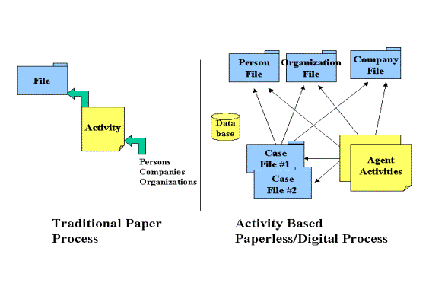
Figure 2: Traditional Paper Process vs. Activity-Based Digital Process.
Electronic Files vs. Paper files-- The core functional operation of an Activity Based system resembles the paper files used to contain the various papers generated to document the investigative actions. The Activity Based system includes the investigative steps as Activities that are associated to the Files much as paper-documented actions are placed in the file folder. Figure 2 also illustrates how the Activity Based system has segregated out Participant information along with File and Activity information. This segregation of these information components commonly contained in paper case files minimizes agent re-entry work and maximizes information re-use. Participant information is further segregated out by types of participants: Person, Company, Organization, and Program. The advantage of this again is to minimize re-entry of data. The agent can capture the fact that an individual is a member of a given organization and then re-use the entered organization information later for other individuals that may be members of the same organization. No retyping organization information multiple times.
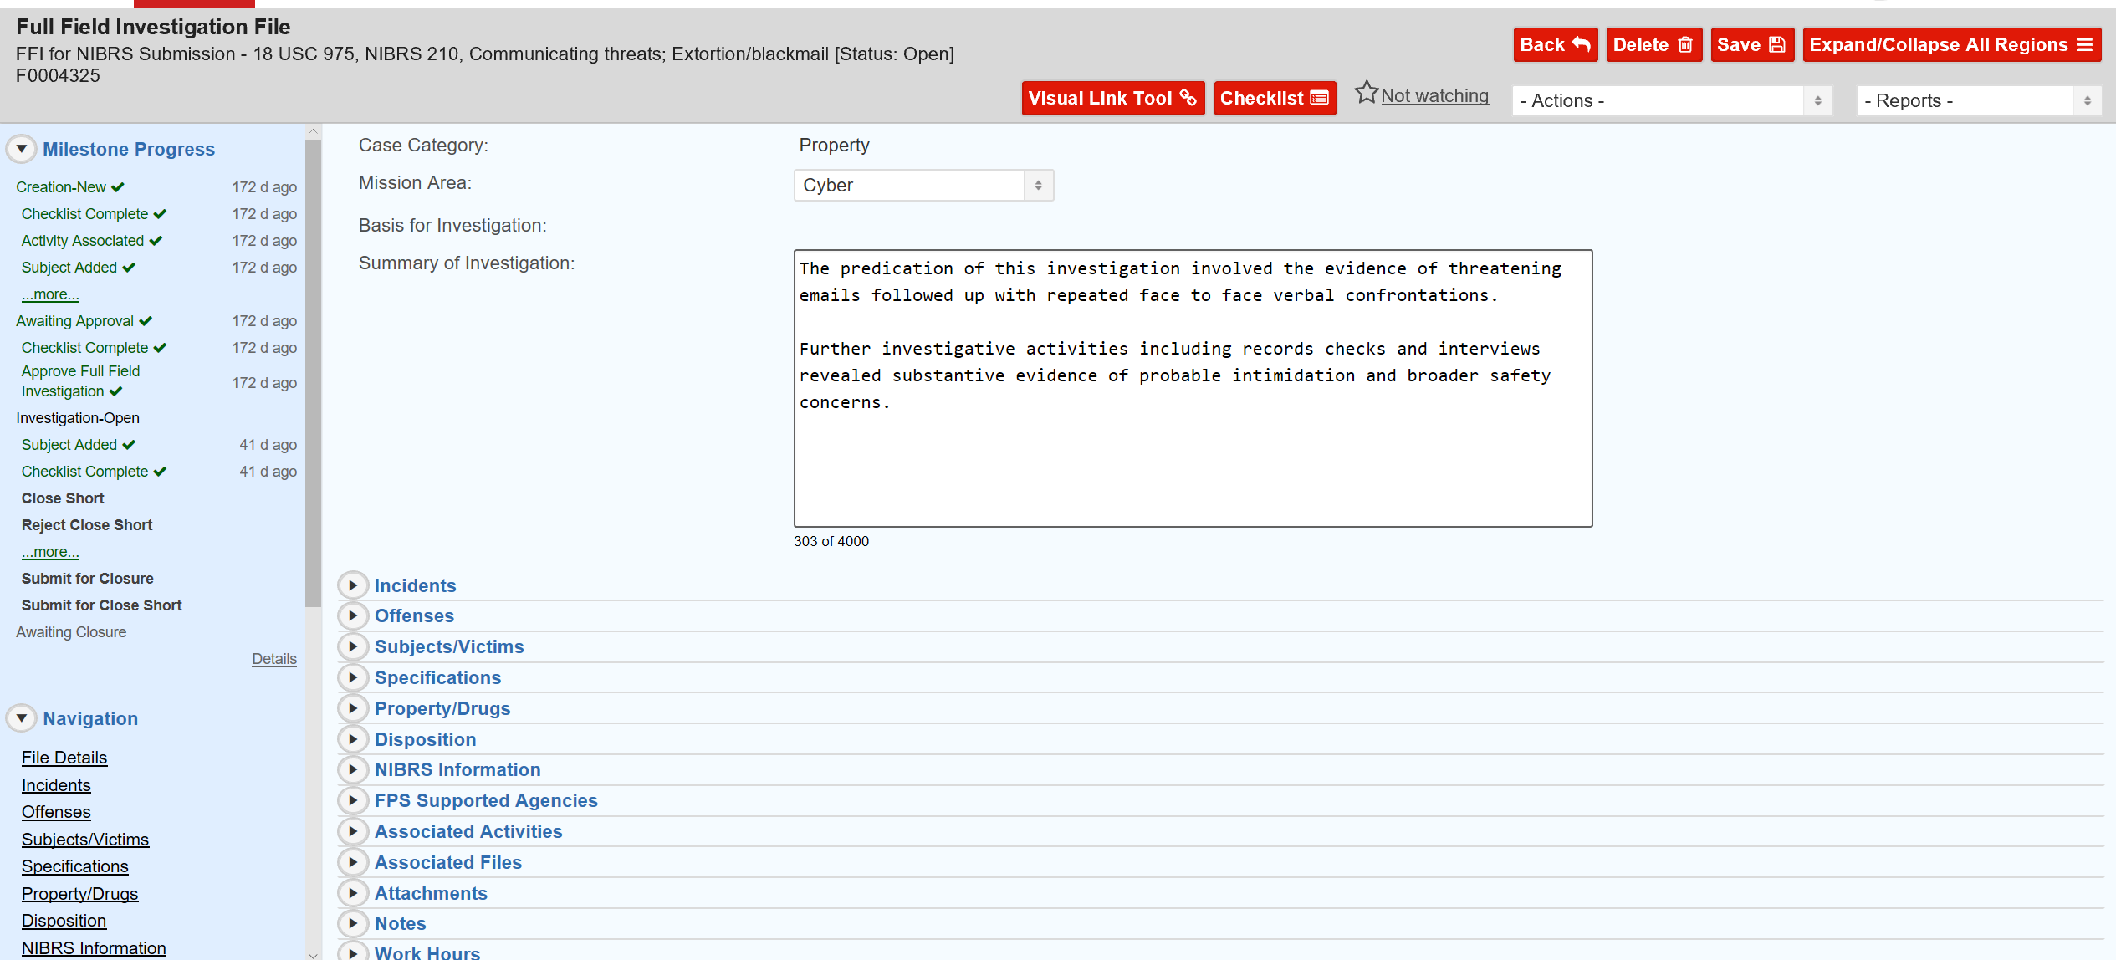
Figure 3—Sample Electronic Case File from I2MS
Although no organization can be completely paperless, the Activity Based system can approach this ideal. This is done not only through the segregation and grouping of data as discussed above, but also by providing electronic tools for those non-paper tasks done by field agents. For helping to determine who is responsible for given cases and what part different agents and agencies might play in a case file, the Activity Based system provides electronic Assignment functionality. For capturing supervisory review of case work, an electronic approval and review note functionality is provided. For supplementary case information (e.g. photos, hard copy documents, audio) an Attachment functionality is available. And for resource allocation to case work (e.g. man hours spent, expenses consumed, equipment used) a Resources functionality is integrated into this paperless system.

Activity Based System Advantages
The primary advantages of the Activity Based I2MS over many existing investigative software systems are:
1) Minimization of duplicate data entry (enter once and reuse by all agents for people, places, property, case information, evidence, equipment, expenses…)
Primarily due to the segregation of data discussed above, agents do not have to enter the same group of data into the Activity Based system more than once. In fact, agent #2 could reused the person information entered by agent #1 and not have to do any data entry
2) Automatic buildup of link analysis data for the investigative analyst
Again, since data is segregated and re-used, the database behind the Activity Based system is automatically structured and available for consumption by many graphing programs:
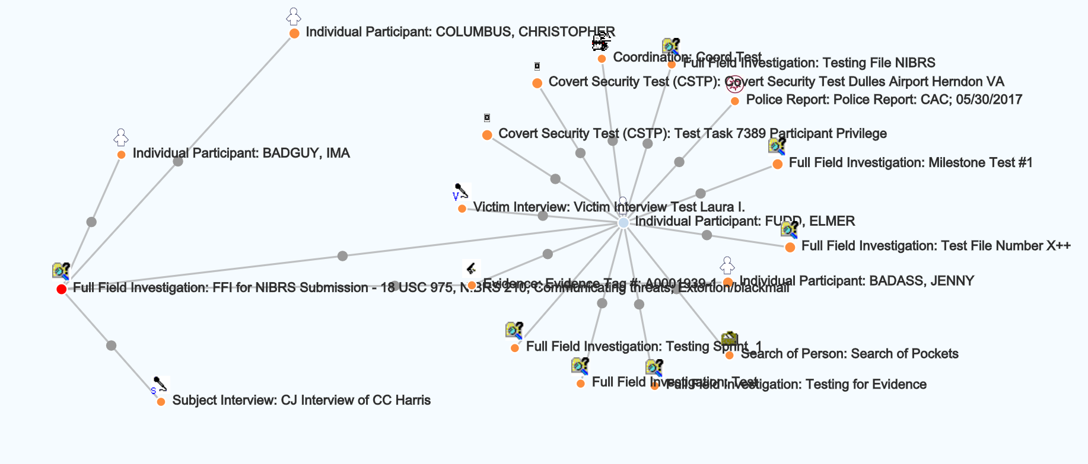
Figure 4 Example graphical link analysis against system data
3) Consolidation of “database silos” (I2MS is one contingent Oracle database)
Since earlier generation management systems must contain the scope of new functionality to meet time and budget constraints, they typically address limited business processes. There exists separate applications and corresponding databases for these separate business processes. There might be an application for lists of case files, one for expenses, another for people, and so on. The next generation Activity based system has built on past applications and integrated into one interface for the agent, and one database for management.
This integration of data, in turn, provides for integration of business processes which, in turn, provides for database integrity. For example, equipment used for a case cannot be checked out without the existence of the case. Or evidence obtained in a Search Activity cannot be processed without existence of the Activity.
4) Agent documentation made as work progresses rather than all at once at deadline
It is not unusual in human nature to put things off until the last minute. This can happen too in documentation of investigations. Multiple interviews, document reviews, and searches may have been done before the time a complete report of investigation is due. The Activity Based system provides for the entry needed for the immediate documentation needs to suffice for the later documentation needs. The agent does not need to what until the last minute to document the case report because the system can generate this report automatically at any time in the case life cycle.
5) Scalable to many users (based on Oracle backend)
An Activity Based system requires more entry than the traditional investigative management system. These systems also require access by all in the organization simultaneously during all parts of the day. A powerful central database is required to serve these demanding needs. Some single user databases (like Microsoft Access) or less powerful, less mature database technologies cannot fit the bill. The powerful Oracle database behind the I2MS system can. This database is scalable to many users as already proven on many existing ERP or large web applications.
6) Strong normalized database behind the user friendly interface (data integrity, growth, and scalability)
A normalized database is one where common groups of information are segregated from one another. Earlier it was shown how Activities, Files, and Participant information is segmented out. This segmentation is carried to much lower levels in the I2MS database structure. A normalized database provides for cost effective database integrity, database growth.
Many IT decision makers do not understand, or care to understand, the importance of a normalized database. It is a technical issue that they should not get involved in. However, many legacy databases are finding limits earlier than expected because the technical architects did not understand the normalized database either.
7) Built in XML Export/Import functionality for data sharing and system to system configuration
Summary
I2MS is the primary investigative support application in a broad range investigative agencies today. Other applications, such as email and Office Automation tools, provide general support but are also key parts of the total investigative support system suite. I2MS documents the investigations. The other products assist in conducting, managing, and documenting the investigations.
However, the activity based system augments other administrative systems already well established (for example, Computer Aided Dispatch). With the XML capabilities of the Activity Based system, integration with existing databases is straightforward.

